

Figure 1. Apalachicola River mean daily discharge (1000’s of CFS) from USGS station 02358000 (Chattahoochee) from January 1, 1950-March 2019.

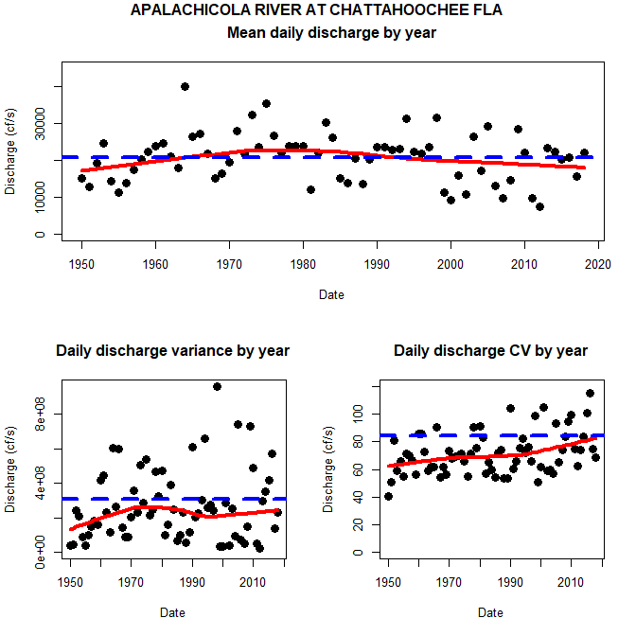

Figure 2. Apalachicola River mean daily discharge (1000’s of CFS) from USGS station 02358000 (Chattahoochee) from 1950-2018. The thick blue line in each graph is the value (mean, variance or discharge depending on graph) for the period of data used. The red line is a lowess smoothing line just for visualization. The dots colors are the quantiles (0 to 100) so the 50% quantile is the median. The thick black line is the discharge for a given year. As an example 2007 much of the year was in the first quantile 0-25% where as 2014 was in the 75-100% quantile. It is interesting that there is contrast in these data with years including 2006-2008, 2011 and first part of 2012 as generally below median (or below 25% quantile) and the years since mid 2012-2018/2019 (so far) above median.



Figure 3. Various river discharge plots for Apalachicola River discharge (1000’s of CFS) from USGS station 02358000 (Chattahoochee) from 1950-2018.

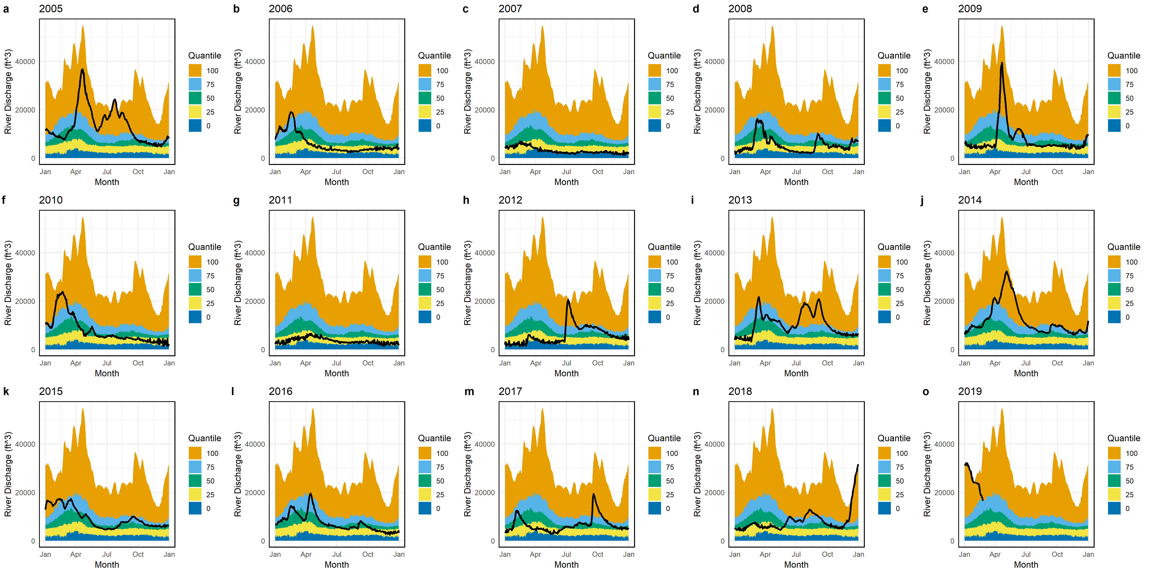

Figure 4. Apalachicola River mean daily discharge (1000’s of CFS) from USGS station 02358000 (Chattahoochee) from 2005-2019. The colors are the quantiles (0 to 100) so the 50% quantile is the median. The thick black line is the discharge for a given year. As an example 2007 much of the year was in the first quantile 0-25% where as 2014 was in the 75-100% quantile. It is interesting that there is contrast in these data with years including 2006-2008, 2011 and first part of 2012 as generally below median (or below 25% quantile) and the years since mid 2012-2018/2019 (so far) above median.



Figure 5. Duration curves for river discharge (y axis, CFS) using Apalachicola River mean daily discharge (1000’s of CFS) from USGS station 02358000 (Chattahoochee). The black line in both plots is for a time period from 1050-2018. The red line on the plot on the left is for a time period from 2005-2013 and on the right from 2014-2018. Again, contrast in these data with the 2005-2013 period generally much lower than the 1950-2018 data set where as in more recent years 2014-2018 similar to the longer term record.